**Receipts and Supporting Documentation**

**All finance requests must be supporting by correct documentation.**

**Money Request**

**Valid Documentation -** A valid receipt/invoice must show:

Date of the purchase

Name of the supplier

Item(s) purchased

Cost of the purchase (including a VAT breakdown and VAT registration no., if applicable)

Supplier invoice must be marked as paid or supported by proof of payment

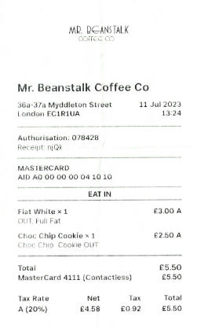 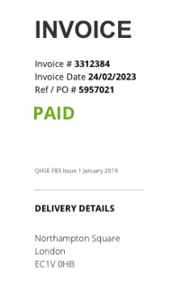

 Faded receipt

 Card transaction only receipt

Bank transaction screenshots



 Missing information

 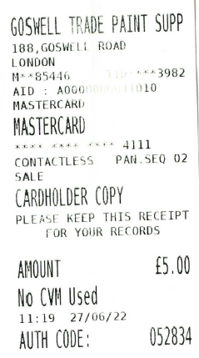

**Sales Invoice Request**

**Valid Documentation – Sponsorship**

Sponsorship contract signed by the sponsor and appropriate member of the Students’ Union

**Valid Documentation – Donation**

A letter/email from the organisation (or department) with the following information:

- Donor’s name

- Donor’s address

- The following text: “we are pleased to donate the sum of £x to City Students’ Union *insert society*. This is a donation and we expect nothing in return.”