Submitting Finance Requests

Student Group Finances (SGF) allows committee members of societies and members of sport clubs to submit finance request.

Login to the citystudents.co.uk website and then go to your society/club page.
Scroll to the bottom of the page and click on 'Finance requests'.
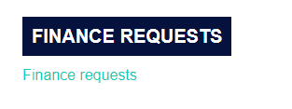
Submitting a Finance Request
Society committee members and Club members can raise the following Finance Requests;
- Money Request - reimbursement of expenses or for the Students’ Union to pay a supplier invoice.

- Purchase Request – for the Students’ Union to place the order and process the payment.

- Sales Invoice – for the Students’ Union to raise a sales invoice for income.

The request will follow the following process - Member submits a finance request > President/Finance Officer approve the request > Communities Team approve the request > Finance team make payment or raise a customer invoice.
The correct supporting documentation must be uploaded as evidence. All payments are process by a bank transfer.

- How to create a new Money Request

Click on + New Money Request
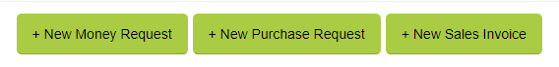
Fill out the details for your payment request.

Request Type
- Select Reimbursement if you have paid for something already and wish to claim the money back.
- Select Pay Supplier Invoice if you need the Students’ Union to pay an invoice. The supplier invoice must be addressed to the Students’ Union.

Event
- Select the event name from the drop-down list, if your payment relates to a specific event. If not, just select 'not associated with an event’.
Payable To
- Select Requester if you are claiming a reimbursement.
- Select Other Student if you are submitting a reimbursement on another member’s behalf. You will need to provide the members payee name, contact email/telephone number and bank sort code and account number.
- Select Third Party if you have selected Pay Supplier Invoice in the request type field. You will need to provide the suppliers’ payee name, contact email/telephone number and bank sort code and account number.
Payment Method
- All payments will be processed by BACS (bank transfer). Please ensure you check the bank sort code and account number provided.

Item description
- Provide a brief description of the item(s) you have purchased or would like to purchase.
Justification
- Provide a brief description of why you have purchased or are buying the item(s).
Gross Amount
- The total amount of your request.
Account
- Select Society Funded Expense if the request is funded by the Society.
- Select Grant Funded Expense if the request is funded by Development Grant.
Tax
- This will be completed by the Finance Team.

Upload Receipt / Supporting Documentation
- Upload a copy of the receipt/invoice linked to your request. Make sure it is clear to read and matches the total amount stated in your request.

- Click on the Browse button to select for file.

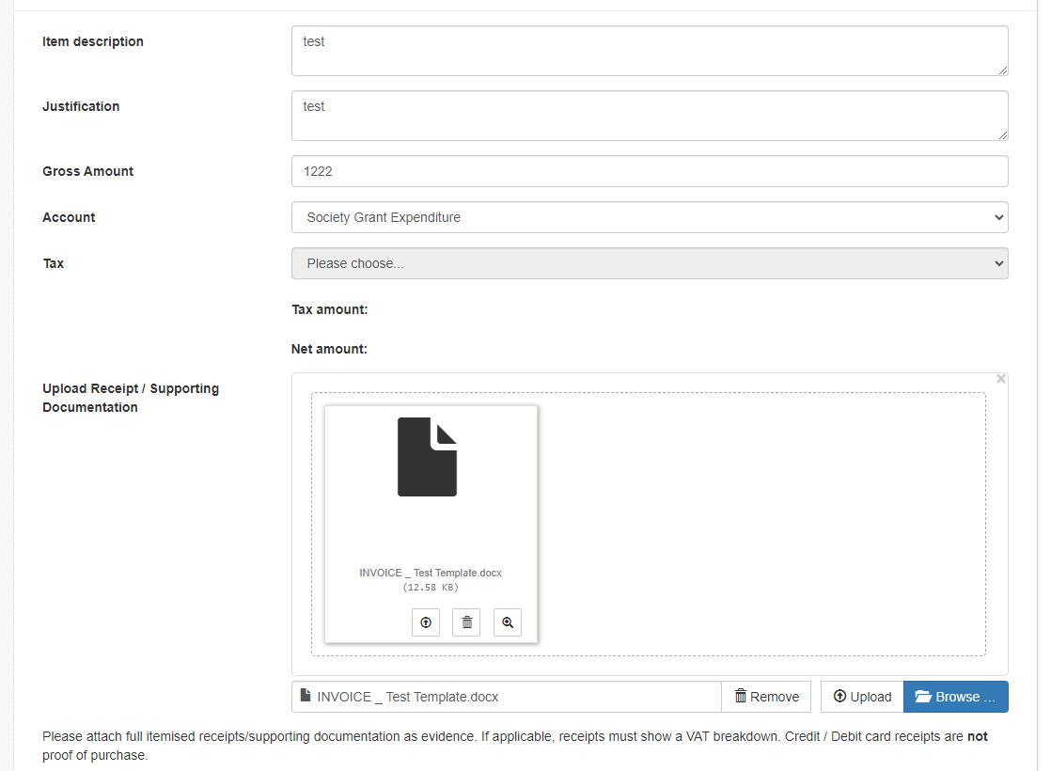

- You MUST upload a receipt/supporting document to be able to create/submit a request.

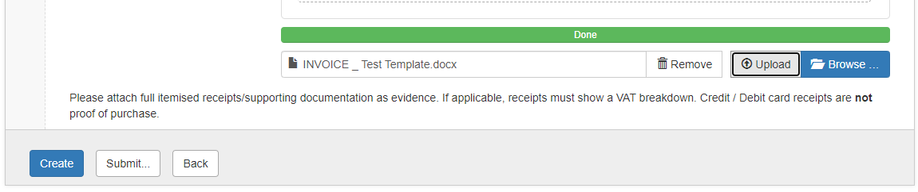

Create
- Click on the Create button if you would like to add another line or if you would like to save your request as a draft.

- To add another line, click on the Add Item button and complete the fields.
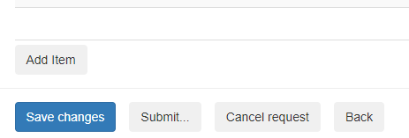

- Upload a receipt/supporting document then click on Add.
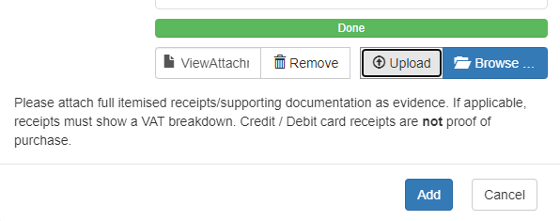

Submit
- Click on Submit when you are ready to submit your request for approval.
- The status of a request can be viewed at any time via the dashboard.

- How to create a new Purchase Request

Click on + New Purchase Request
Fill out the details for your purchase request.
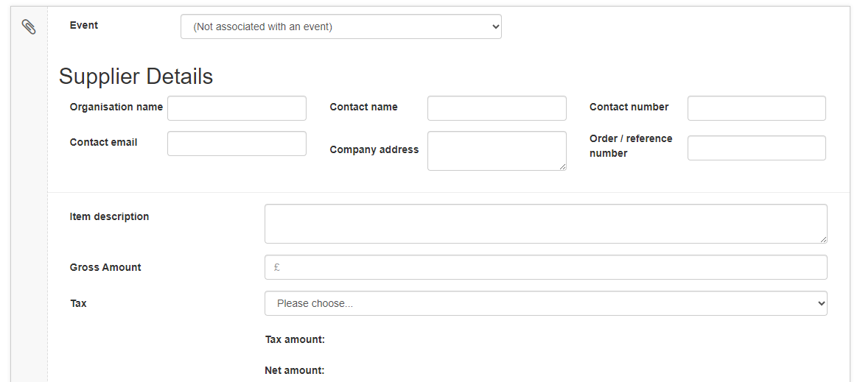

Event
- Select the event name from the drop-down list, if your purchase relates to a specific event. If not, just select 'not associated with an event’.
Supplier Details
- Complete the supplier details fields
Item description
- Provide a brief description of the item(s) you would like to purchase.
Gross Amount
- The total amount of your request.
Tax
- This will be completed by the Finance Team.

Upload Receipt / Supporting Documentation
- Upload any supporting documents i.e. quotes. Make sure it is clear to read and matches the total amount stated in your request.

(Please follow the instructions on how to upload supporting documentations under the creating a new Money Request section).
Create
- Click on the Create button if you would like to add another line or if you would like to save your request as a draft.

Submit
- Click on Submit when you are ready to submit your request for approval.
- The status of a request can be viewed at any time via the dashboard.

- How to create a new Sales Invoice

Click on + Sales Invoice

Fill out the details for your sales invoice request.

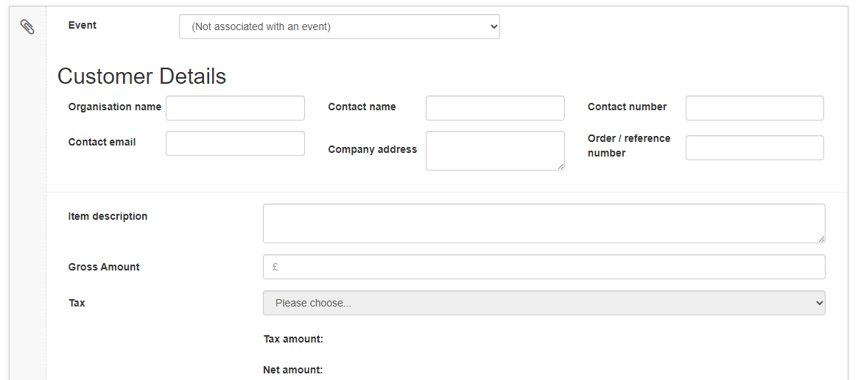
Event
- Select the event name from the drop-down list, if your income relates to a specific event. If not, just select 'not associated with an event’.
Customer Details
- Complete the customer details fields
Item description
- Provide a brief description of the item(s) you would like to raise a sales invoice for. This can be for a sponsorship or donation.
Gross Amount
- The total amount of your request.
Tax
- This will be completed by the Finance Team.

Upload Receipt / Supporting Documentation
- Upload any supporting documents i.e. signed sponsorship contract or donation confirmation document. Make sure it is clear to read and matches the total amount stated in your request.

(Please follow the instructions on how to upload supporting documentations under the creating a new Money Request section).
Create
- Click on the Create button if you would like to add another line or if you would like to save your request as a draft.
Submit
- Click on Submit when you are ready to submit your request for approval.
- The status of a request can be viewed at any time via the dashboard.

