Approving Finance Requests

To approve a finance request, the approver will need to log into the Student Group Finances (SGF) system.

Login to the citystudents.co.uk website and then go to your society/club page.
Scroll to the bottom of the page and click on 'Finance requests'.
You will be able to view a list of requests and the current status on their dashboard.
Click on a request to view the details.

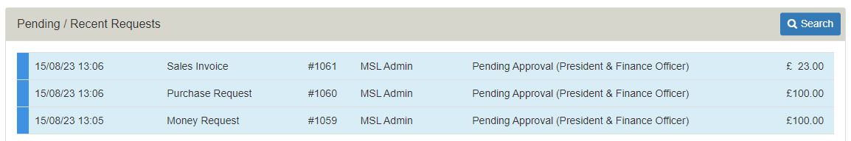

You can view all the request details and have the option to approve or refer the request back to the requester for additional information or correction.
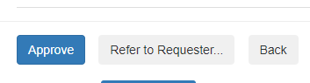
Refer to Requester
- Click on Refer to Requester to refer the request back to the requester. The approver must add notes to explain why they are unable to approve the request.
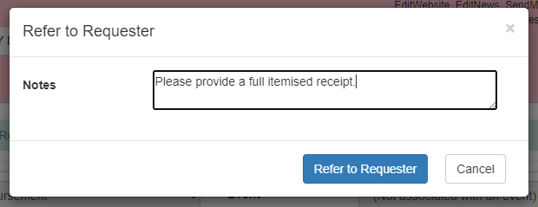

Approve
- Click on Approve to progress the request to the next stage.

The Communities Team will review the request and may reject or refer the request back for additional information or correction.

